**COVER PAGE**

***Instructions:*** *Complete the space to the right of the grayed area with the requested information.*

|  |  |  |
| --- | --- | --- |
| **Federal Agency** | National Nuclear Security Admin NA-221 | |
| **Award Number** | DE-NA0003920 | |
| **Institution Name** | University of Michigan | |
| **Investigator name** | Prof. Sara Pozzi | |
| **Project Title** | Consortium for Monitoring, Technology, and Verification | |
|  | | |
| **PD/PI Information** | Name | David Wehe |
|  | Title | MTV Chief Scientist |
|  | Institution | University of Michigan |
|  | Email | [dkw@umich.edu](mailto:dkw@umich.edu) |
|  | Phone | **(734) 763-1151** |
|  | | |
| **Thrust Area** | TA1: Fundamentals of Nuclear and Particle Physics | |
| **Thrust Area Lead** |  | |
|  | | |
| **Recipient Organization** | Name | Regents of the University of Michigan  Attn: Kullie Kennedy |
|  | Address-a | 1058 Wolverine Tower - ORSP |
|  | Address-b | 3003 South State Street  Ann Arbor, MI 48109-1274 |
|  | | |
| **Project Grant Period** | 09/01/2019 – 08/31/2020 | |
| **Reporting Period End** | 6/30/2021 | |
| **Report Frequency** | Quarterly | |

***NOTE: Only report on activities accomplished over the reported quarter.***

**ACCOMPLISHMENTS**

**GOALS**

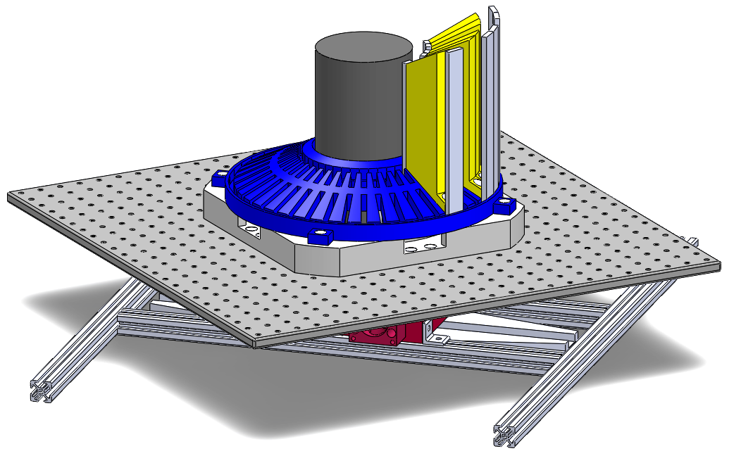Explore time-encoded imaging (TEI) for neutron/gamma-ray sources.

Time-encoded imaging (TEI) was invented at Michigan for nuclear medicine imaging. The technique has the advantage of encoding source radiation through a time-varying mask pattern on a single detector rather than encoding the source radiation through a fixed mask in space on an array of detectors. The advantage of the TEI technique is simplicity and cost, while the disadvantage is typically a longer acquisition time. When multiple imaging systems are desired, the TEI advantages may prove dominant.

**WORK PERFORMED**

Time Encoded Fast Neutron Imaging Project (LANTERN)

During this quarter, we have been working on MTV successor to the MATADOR system -- a handheld TEI system (LANTERN).

During this quarter, we have made several advances:

* working with Sandia National Laboratories on simulating random mask patterns and creating response maps and geometries for the most promising patterns.
* worked on the electronics and code that allows the rotary table to move.
* measured several cesium sources to view count rate modulation with the system for the first time.
* continued development of post processing code for image creation.

Fig. 1: LANTERN with a 3-layer mask (tungsten-polycarbonate-tungsten).

Figure 1 shows the assembled LANTERN time-encoded imager. A 2” trans-stilbene crystal was used as the detector, coupled to a SensL J-Series SiPM. SiPMs avoid high voltage and offer a more compact design than its predecessor. The rotary table now turns in conjunction with the stepper motors. The major effort this past quarter involved debugging the software interface to the stepper motors and understanding the CAEN COMPASS software for waveform analysis.



Fig. 2: Mask Pattern overlayed on the counts over time from a single rotation measurement.

Figure 2 shows the first results obtained using LANTERN with a Cs-137 check source. ~n energy window set eanythose sections These first test results indicate that the system appears to be mechanically and electronically functioning as intended.

**METHODS OF DISSEMINATION TO COMMUNITIES OF INTEREST**

N/A

**STRATEGY TO ACCOMPLISH GOALS DURING NEXT REPORTING PERIOD**

In addition, the graduate student involved has been working as a year round virtual student intern for the Radiation and Nuclear Detection Systems group at Sandia National Laboratories in Livermore, CA.

We plan to continue the work described above during the upcoming quarter. The graduate student is utilizing the collaboration with Sandia National Laboratories to better understand the design and manufacturing of cTEI imagers. They are also working using Sandia codes to optimize the coded aperture mask pattern for LANTERN. The graduate student is working on preparing the system for an oral presentation at UPR in the fall.

**PRODUCTS**

PEER REVIEWED JOURNAL PUBLICATIONS

|  |  |  |
| --- | --- | --- |
| **Publication details: author(s), title, journal, volume, page numbers, year** | **Nat’l Lab Collab?** | **Nat’l Lab co-authors** |

CONFERENCE PAPERS

|  |  |  |  |
| --- | --- | --- | --- |
| **Paper details: author(s), title, conference_name, dates, location_of_conference** | **Poster/ Talk** | **Nat’l Lab Collab?** | **Nat’l Lab co-authors** |

PRESENTATIONS OTHER THAN THOSE REPORTED ABOVE

|  |  |  |  |
| --- | --- | --- | --- |
| **Presentation details: author(s), title, event_name, dates, location_of_event, presenter_status: (faculty, postdoc, graduate student, undergrad)** | **Poster/ Talk** | **Nat’l Lab Collab?** | **Nat’l Lab collaborators** |
| **J.R.Kuchta(Ph.D. Candidate)\***, N.P.Shah(Ph.D.), P.Marleau(SNL), D.K.Wehe(Faculty) “Time-Encoded Dual Particle Imager (lanTErn)” *MTV March 2021 Workshop*, March 2021. | Talk | Y | SNL |

THESIS and DISSERTATIONS

|  |  |  |  |  |  |
| --- | --- | --- | --- | --- | --- |
| **Student Name** | **Degree earned** | **Date completed** | **Dept. name** | **Nat’l Lab collaborator on committee** | **Nat’l Lab collaborator (name, Lab)** |

INVITED TALKS (talks given by you)

|  |  |  |
| --- | --- | --- |
| **Presentation details: presenter(s), title, event_name, dates, location_of_event** | **Nat’l Lab Collab?** | **Nat’l Lab collaborators** |

SEMINARS (talks given by invited guests at your institution)

|  |  |  |
| --- | --- | --- |
| **Seminar details: presenter(s), title, event_name, dates, location_of_event** | **Nat’l Lab Collab?** | **Nat’l Lab collaborators** |

educational aids OR curricULA

The grad student assisted as a student course coordinator for the nuclear physics course at the University of Michigan in the department of Nuclear Engineering and Radiological Sciences.

COURSE DEVELOPMENT (new courses, short courses, workshops, courses enhanced)

|  |  |  |
| --- | --- | --- |
| **Course details: course_number, course_name, lead_instructor_name, course_description, number_of_students** | **Nat’l Lab Collab?** | **Nat’l Lab collaborators** |

GRADUATED FELLOWS

|  |  |
| --- | --- |
| Student’s Name | N/A |
| Program | N/A |
| Date of Graduation | N/A |
| Degree Earned | N/A |
| Degree Date | N/A |
| Current Employer or Program (i.e. grad school) | N/A |

**WEBSITE(S) OR OTHER INTERNET SITE(S)**

N/A

**DEVELOPED TECHNOLOGIES OR TECHNIQUES**

N/A

**Inventions, patent applications, and/or licenses**

N/A

**Other products, such as data or databases, physical collections, audio or video products, software or NetWare, models, instruments, or equipment**

N/A

**Any other public release of information related to the project**

N/A

**PARTICIPANTS & OTHER COLLABORATING ORGANIZATIONS**

PROJECT PARTICIPANT

|  |  |
| --- | --- |
| Name | *John R. Kuchta* |
| Project Role | *MTV Graduate Fellow* |
| Nearest Person Month Worked |  |
| Contribution to Project | *Lead Designer and Researcher* |
| Funding Support | *(complete only if the funding provided is from other than this award)* |
| Collaborated with individual in a foreign country | *No* |
| Country(ies) of foreign collaborator: | *(if “Yes” is answered in the previous question)* |
| Travelled to foreign country | *No* |
| Country(ies) traveled to | *(if “Yes” is answered in the previous question)* |
| Duration of stay | *(if traveled to foreign country(ies))* |

NATIONAL LAB COLLABORATIONS

|  |  |
| --- | --- |
| Laboratory Name | Sandia National Laboratories |
| Name of Collaborators | Peter Marleau, Melinda Sweaney |
| Participating Fellows or Associates |  |

OTHER PARTICIPATING ORGANIZATION

|  |  |
| --- | --- |
| Organization Name |  |
| Primary Contact Name |  |
| Location of Organization | *(if foreign location list country)* |
| Partner’s contribution to the project | *(see instructions for a list of options)* |
| More detail on partner and contribution | *(foreign or domestic)* |

**IMPACT**

**IMPACT ON THE DEVELOPMENT OF PRINCIPAL DISCIPLINE(S) OF PROJECT**

Work with Sandia National Laboratories will produce several optimized coded aperture mask patterns for use in the LANTERN project for different applications.

**IMPACT ON THE OTHER DISCIPLINES**

N/A

**IMPACT ON THE DEVELOPMENT OF HUMAN RESOURCES**

N/A

**impact on physical, institutional, and informational resources that form infrastructure**

N/A

**impact on technology transfer**

N/A

**impact on society beyond science and technology**

N/A

**dollar amount of the MTV award’s budget being spent in foreign country(ies)**

$0.00

**CHANGES/PROBLEMS**

**Changes in approach and reasons for change**

N/A

**Actual or anticipated problems or delays and actions or plans to resolve them**

N/A

**Changes that have a significant impact on expenditures**

N/A

**Significant changes in use or care of animals, human subjects, and/or biohazards**

N/A

**Change of primary performance site location from that originally proposed**

N/A

**SPECIAL REPORTING REQUIREMENTS**

* Respond to any special reporting requirements specified in the award terms and conditions, as well as any award specific reporting requirements.